|  |  |
| --- | --- |
| **SQL** | **DERIVED** |
| UPDATE Atrack_Event_Ticket_DataStaging  SET Reason_ID = 1  WHERE Reason_ID IS NULL | ISNULL(Reason_ID) ? 1 : Reason_ID |
| UPDATE Atrack_Event_Ticket_DataStaging  SET Event_User_Id = @Saphire  WHERE Event_User_Id = @AI_Auto | [Event_User_Id] ==@[User::AI_Auto] ? @[User::Saphire] : [Event_User_Id] |
| UPDATE atrack_AITicket_Track_Staging  SET Update_Emp_id = 'Saphire'  WHERE Update_Emp_id is NULL  OR Update_Emp_id = 'AI'  OR Update_Emp_id = 'AI_Auto' | ( ISNULL( [Update_Emp_ID] ) || [Update_Emp_ID] =="AI" || [Update_Emp_ID] =="AI_Auto" ) ? @[User::Saphire] : [Update_Emp_ID] |
| UPDATE Atrack_Event_Ticket_DataStaging  SET Event_User_ID= Event_User_ID % 1000000  WHERE Event_User_ID > 999999 | [Emp_id] > 0 ? [Emp_id] % 1000000 : [Emp_id]  Emp_id is int |
| UPDATE Atrack_Event_Ticket_DataStaging  SET Emp_ID = Emp_ID % 1000000  WHERE isnumeric(Emp_ID ) > 0  AND Emp_ID > 999999 | (DT_I4)(**Emp_id**) > 0 ? (DT_I4)(**Emp_id**) % 1000000 : (DT_I4)(**Emp_id**)  Emp_id is string  (!ISNULL (Emp_id) && (DT_14)(Emp_Id) > 0 ) ? |

UpdatedBy == "atrk" ? "-1" : UpdatedBy

CONVERT TO UTC DATEADD("second", DATEDIFF("second", GETDATE(), GETUTCDATE()), [Update_Time])

((DT_STR,20,1252) [Emp_Id] == ((DT_STR,20,1252) (DT_I4) [Emp_Id] )) ? (DT_I4)(Emp_Id) % 1000000 : (DT_I4)(Emp_Id)

El problema es que despues se necesita que guarde un string, y si Emp_Id no es numero da problema. De lo contrario use

UPDATE Atrack_Event_Ticket_DataStaging

SET Emp_ID = Emp_ID % 1000000

WHERE isnumeric(Emp_ID ) > 0

AND Emp_ID > 999999

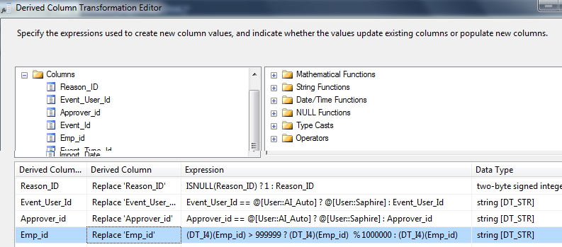

Because Emp_id has 2 derives

!ISNULL( )

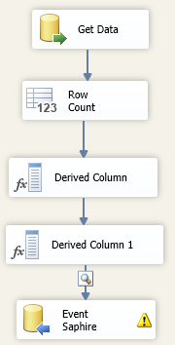

**Manage Derived problems – IsNumeric**

(DT_I4)(**Emp_id**) > 0 ? (DT_I4)(**Emp_id**) % 1000000 : (DT_I4)(**Emp_id**)

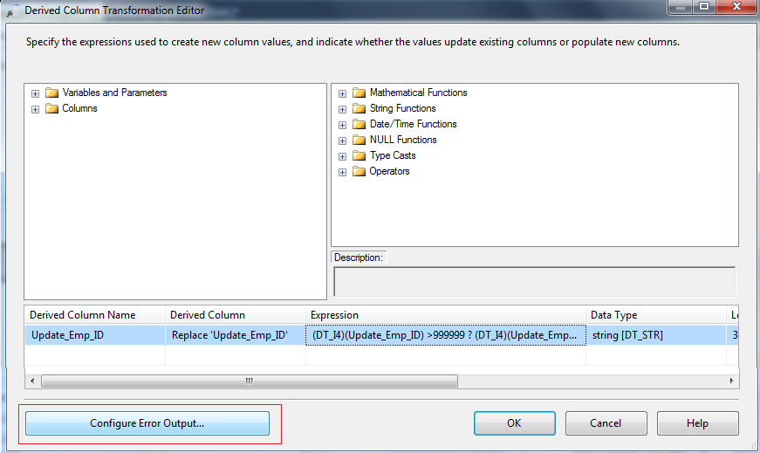

Set ignore error

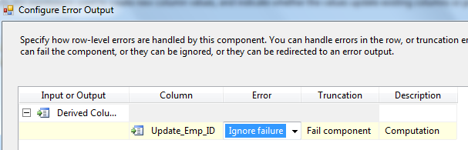

* Ignore Failure: Inserta NULL en campo error
* Redirect Row: Elimina toda la fila
* Fail Component: Aborta proceso

ISNULL(Reason_ID) ? 1 : Reason_ID

(ISNULL(Approver_id) || Approver_id == "AI" || Approver_id == "AI_Auto") ? @[User::Saphire] : Approver_id

(ISNULL(Event_User_Id) || Event_User_Id == "AI" || Event_User_Id == "AI_Auto") ? @[User::Saphire] : Event_User_Id

CONVERT TO UTC DATEADD("second", DATEDIFF("second", GETDATE(), GETUTCDATE()), [Update_Time])

(DT_I4)(Event_User_Id) > 0 ? (DT_I4)(Event_User_Id) % 1000000 : (DT_I4)(Event_User_Id)

(DT_I4)(Approver_id) > 0 ? (DT_I4)(Approver_id) % 1000000 : (DT_I4)(Approver_id)

SET NULL WHEN INT

((DT_I4)(Approver_id) == 86 && Location == "DO San Isidro") ? **NULL(DT_I4) :** (DT_I4)(Approver_id)